**SQL_Data Modeling**

**The data model** gives us a preview of what the finished system would look like after full implementation. It describes the data items and the connections between them.

**TYPES OF DATA MODELS**

1. **Hierarchial Data Model**

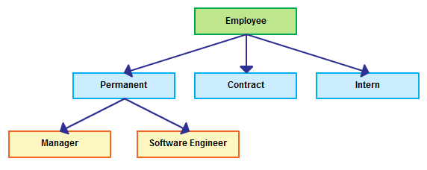

1. **Network Data Model**

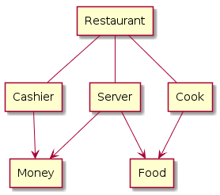

1. **Entity Relationship Data Model**

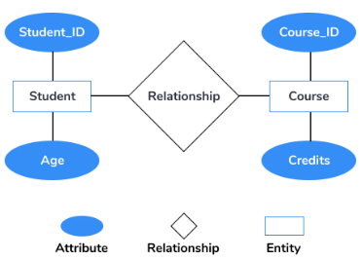

1. **Relational Data Model**

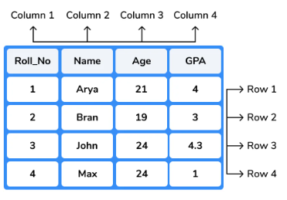

1. **Object Oriented Data Model**

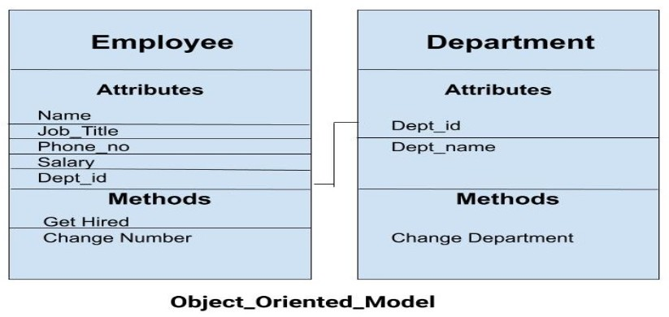

**Data Modeling**

Data modeling is the process of analyzing and defining all the different data your business collects and produces, as well as the relationships between those bits of data.

**Levels of Data Modeling**

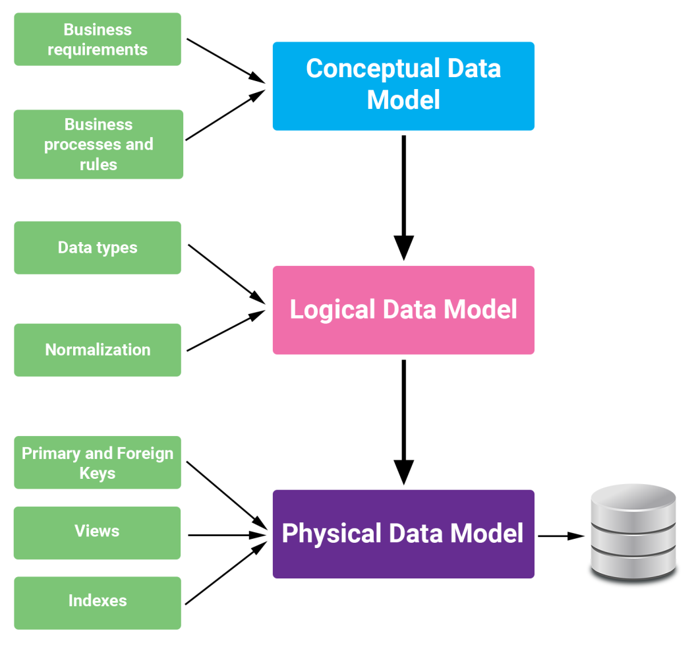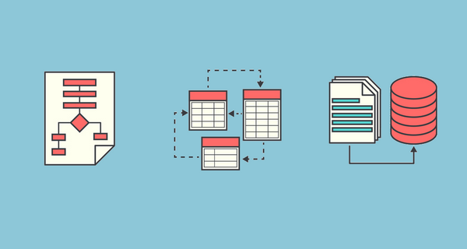

* **SQL Forward Engineering:**

Forward engineering enables you to create a script of your database model. You may export a script to alter an existing database or create a new database.

**Model (ERD)**

**SQL Script**

1. **Let’s perform SQL forward engineering by creating a model and converting it into a SQL script.**

|  |
| --- |
| Bus |
| Bus_ID |
| Start |
| Destination |
| Pickup time |
| Driver |

Schema –

|  |
| --- |
| Student |
| ID |
| Name |
| DOB |
| Address |
| Teacher_ID |
| Bus_ID |

|  |
| --- |
| Teacher |
| Teacher_ID |
| Teacher_name |
| DOB |
| Department |
| Salary |

